**ER Diagram:**

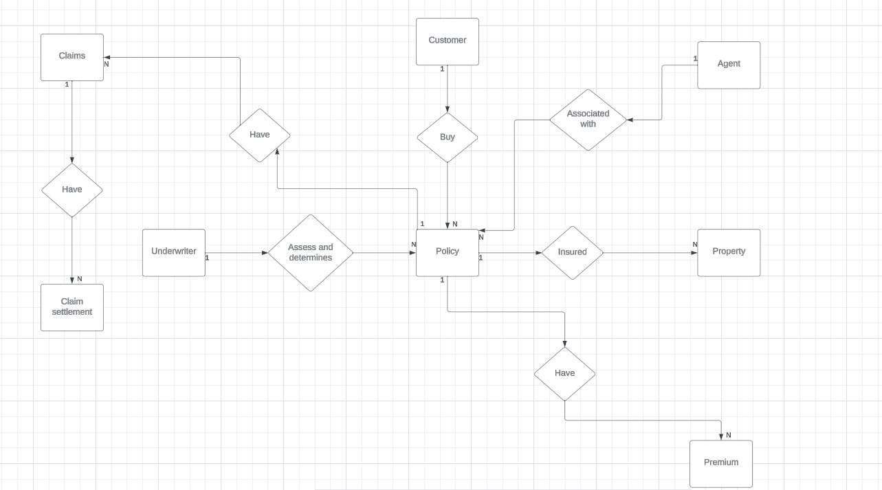

**Logical Diagram:**

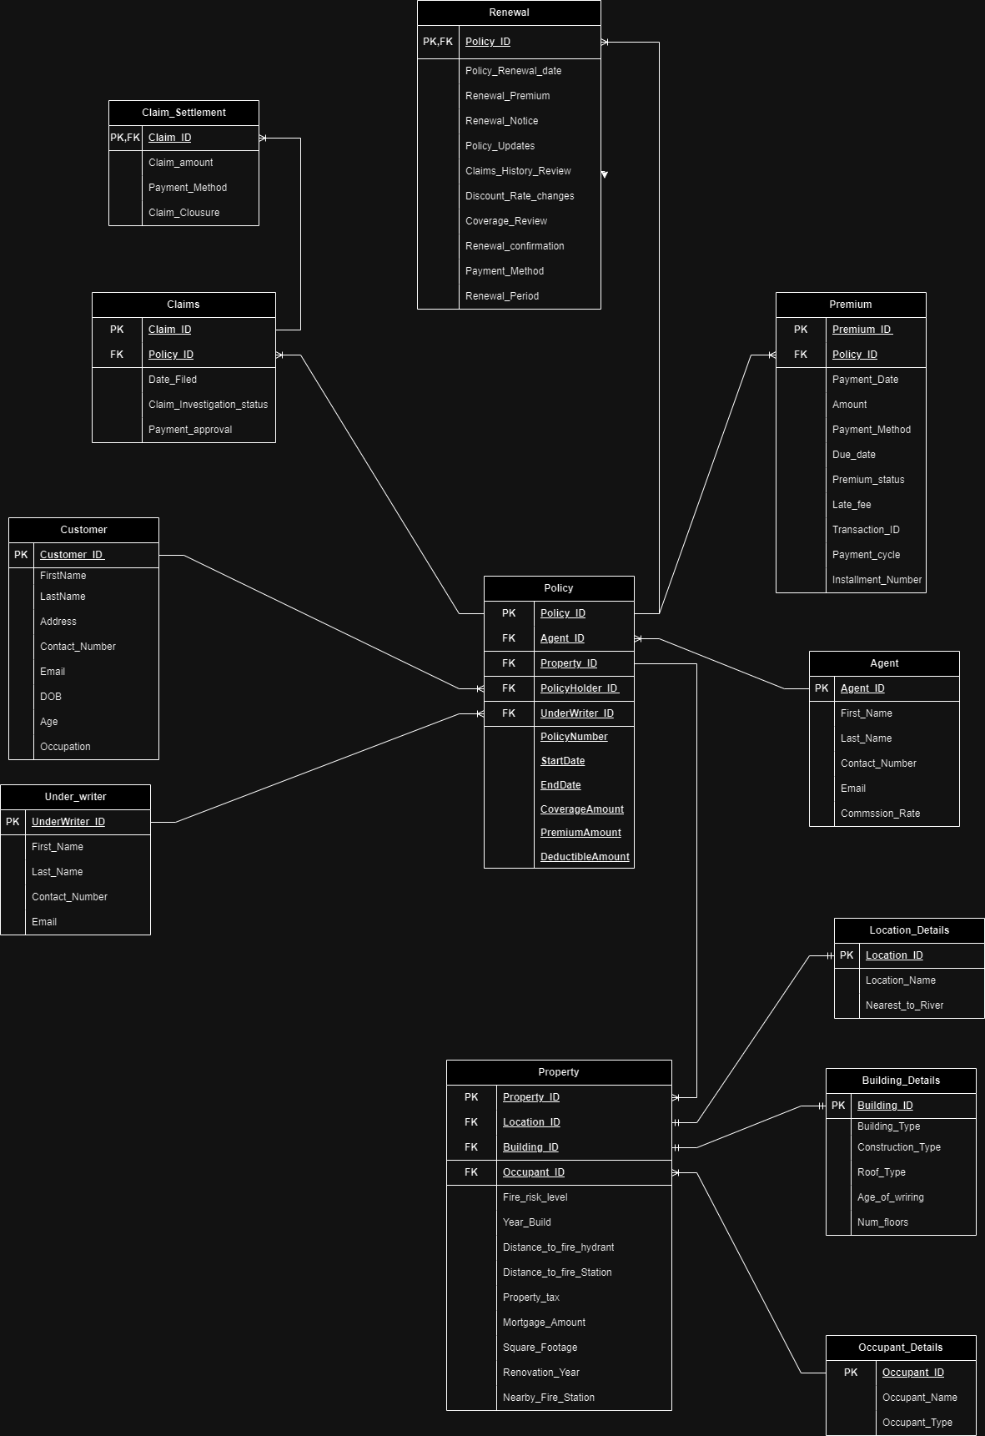

**Entity Details**

**Customer**: Who wants take the policy (Policy holder)

CustomerID (Primary Key) String

FirstName String

LastName String

Address String

ContactNumber Integer (Check) whether it contains 10 digits or not

Email String (Check) whether it is valid Email ID

DateOfBirth Date

Age Integer (Check) whether it is positive number only

Occupation String

**Agent**: Goes towards the customer and explains about the Policies and Made him to pick one based on his/her needs.

AgentID (Primary Key) String

FirstName String

LastName String

ContactNumber Integer (Check) whether it contains 10 digits or not

Email String (Check) whether it is valid Email ID

CommissionRate Decimal (2,2)

**Policy**: A formal contract or agreement between an insurance company (insurer) and an individual, business, or entity (policyholder).

PolicyID (Primary Key) String

Agent ID (FK) (Referencing to Agent entity)

Property ID (FK) (Referencing to Property ID)

PolicyHolderID (FK) (Referencing to Customer entity)

UnderWriterID (FK) (Referencing to Underwriter entity)

PolicyNumber String

StartDate Date

EndDate Date

CoverageAmount decimal

PremiumAmount decimal

DeductibleAmount decimal

**Claims**: A formal request made by a policyholder to their insurance company for compensation or coverage for a loss or damage covered by the insurance policy.

ClaimID (Primary Key) String

PolicyID (FK) (Referencing to Policy entity)

DateFiled Date

Claim Investigation Status String

Payment Approval String

**Claim Settlement:** Claim settlement involves determining the validity of the claim, calculating the amount payable, and providing financial compensation to the policyholder depending on the terms and conditions outlined in the insurance policy.

ClaimID (PK) (FK) (Referencing to Claims entity)

Claim Amount Decimal

Payment Method String

Claim Closure String

**Property**: Contains information about each insured property.

PropertyID (PK) String

LocationID  (FK) (Referencing to Location entity)

BuildingID      (FK) (Referencing to Building entity)

OccupantID (FK) (Referencing to Occupant entity)

Fire_Risk_Level     String

Year_Built         Date

Distance_to_Fire_Hydrant Decimal

Distance_to_Fire_Station Decimal

Property Tax        Decimal

Mortgage Amount      Decimal

Square Footage      Decimal

Renovation_Year     Date

Nearby_Fire_Station  String

**BuildingDetails**: Contains detailed information about the building construction.

Building_ID (PK)   String

Building Type          String

Construction_Type   String

Roof_Type                    String

Age_of_Wiring        Integer

Num_Floors          Integer

**LocationDetails**: Contains detailed information about the location of the property.

Location_ID (PK)  Integer

Location_Name  String

Nearest_To_River String

**Occupant**: Contains information about the occupants of a property.

OccupantID (PK) String

Occupant_Name String

Occupant_Type String

**Under Writer:**

A professional responsible for evaluating and assessing the risk associated with insuring a person, property, or entity. Underwriters work for insurance companies and play a crucial role in the underwriting process, which involves determining the level of risk that an insurance company is willing to accept for a particular policy and setting the appropriate premium.

UnderWriterID (PK) String

FirstName String

LastName String

ContactNumber Integer (Check) whether it contains 10 digits or not

Email String (Check) whether it is valid Email ID

**Premium:**

The amount of money that an individual or entity (the policyholder) pays to an insurance company in exchange for insurance coverage. Premiums are typically paid at regular intervals, such as monthly, quarterly, or annually, depending on the terms of the insurance policy.

Premium_ID (PK) String

PolicyID (FK) (Referencing to Policy entity)

Payment Date Date

Amount decimal

Payment Method String

DueDate Date

Premium_Status String

LateFee decimal

Transaction_ID String

Payment_Cycle String

Installment_Number String